84. Bruising in Children who are Not Independently Mobile (NIM) Policy.
Policy statement
Our setting will work with children, parents and the community to ensure the rights and safety of children and to give them the very best start in life. Guildford Montessori Nursery School is committed to building a 'culture of safety' in which children are protected from abuse and harm in all areas of its service delivery. Our prime responsibility is the welfare and well-being of each child in our care. As such we believe we have a duty to the children, parents and staff to act quickly and responsibly in any instance that may come to our attention.

Procedures
Bruising is the commonest presenting feature of physical abuse in children. Recent serious case reviews and individual child protection cases both Nationally and locally have indicated that clinical staff have sometimes underestimated or ignored the highly predictive value, for child abuse, of the presence of bruising in children who are Not Independently Mobile (those not yet crawling, cruising or walking independently). As a result there have been a number of cases where bruised children have suffered significant abuse that might have been prevented if action had been taken at an earlier stage.
While it recognises that professional judgment and responsibility have to be exercised at all times, it is a requirement that all children with bruising who are Not Independently Mobile (includes disabled older children who are not independently mobile) be referred to Surrey Safeguarding Children's Board and for a Pediatric opinion.

Definitions
Not Independently Mobile (NIM): a child who is not yet crawling, bottom shuffling, pulling to stand, cruising or walking independently. Includes all babies and infants under the age of 2 years.
Bruising: Extravasations of blood in the soft tissues, producing a temporary, non- blanching discolouration of skin however faint or small with or without other skin abrasions or marks. Colouring may vary from yellow through green to brown or purple. This includes petechiae, which are red or purple non-blanching spots, less than two millimetres in diameter and often in clusters.

Although bruising is not uncommon in older, mobile children, and in some independently mobile children and adults with disability, it is rare in infants that are immobile, particularly those under the age of six months. While up to 60% of older children who are walking have bruising, it is found in less than 1% of Not Independently Mobile infants. Moreover, the pattern, number and distribution of innocent bruising in non-abused children is different to that in those who may have been abused.
Patterns of bruising suggestive of physical child abuse include:
- Bruising in children who are Not Independently Mobile, particularly those under 6 months of age;
- Bruises that are away from bony prominences;
- Bruises to the face, back, abdomen, arms, buttocks, ears and hand;
- Multiple or clustered bruising;
- Imprinting and petechiae;
- Symmetrical bruising.
A bruise whatever its size must never be interpreted in isolation and must always be assessed in the context of medical and social history, developmental stage and explanation given. A full clinical examination and relevant investigations must be undertaken.
The younger the child the greater the risk that bruising is non-accidental and the greater potential risk to the child.

This policy relates only to bruising in children who are Not Independently Mobile however any bruising, or suspected bruising, in a child of any age that is observed by, or brought to the attention of, nursery school staff should be taken as a matter for inquiry and concern.
Accidental and innocent bruising is significantly more common in older mobile children, however mobile children who are abused may also present with bruising. Body map must be completed in all cases.
It should be noted that children may be abused (including sustaining fractures, serious head injuries and intra-abdominal injuries) with no evidence of bruising or external injury.
Innocent Bruising. It is recognised that a small percentage of bruising in Not Independently Mobile children will have an innocent explanation (including medical causes). Nevertheless because of the difficulty in excluding non-accidental injury, practitioners should seek advice from a consultant paediatrician and from Surrey Children's Single Point Of Access (C-SPA) in all cases. Children should not be examined by any professional other than a medical practitioner.
The examining medical practitioner should obtain relevant information from all available sources e.g.: health visitor, GP, Hospital records, social services, nursery school etc. which helps in informed decision making.

Occasionally spontaneous bruising may occur as a result of a medical condition such as a bleeding disorder, thrombocytopenia or meningococcal or other acute infection. Child protection issues should not delay the referral of a seriously ill child to acute paediatric services.

It is the responsibility of Surrey Children's Services in conjunction with the local acute or community paediatric department to decide whether the circumstances of the case and the explanation for the injury are consistent with an innocent cause or not.

Emergency Admission to Hospital. Any child who is found to be seriously ill or injured, or in need of urgent treatment or further investigation, should be referred immediately to hospital.
Such a referral should not be delayed by a referral to Surrey Children's Services, which, if necessary, should be undertaken from the hospital setting.
However it is the responsibility of the professional first dealing with the case to ensure that, where appropriate, a referral to Surrey Children's Services has been made.
In the case of newborn infants where bruising may be the result of birth trauma or instrumental delivery, professionals should remain alert to the possibility of physical abuse.

Referral to Children’s Single Point of Access (C-SPA). In Not Independently Mobile children, the presence of any bruising, of any size, in any site should initiate a referral to children’s services.

It is the responsibility of the first professional who learns of or observes the bruising, to inform immediately the nursery school’s DSL or deputy DSL and to make the referral by telephone to Surrey Children's Services or the Emergency Duty Team (EDT).

Surrey Children's Single Point of Access (C-SPA) 0300 470 9100
Emergency Duty Team 01483 517898

All telephone referrals must be followed up within 48 hours with a written referral, using the request for support form and must be fully documented in the patient records. The telephone referral should be made immediately to C-SPA. Outside of normal working hours contact the EDT.
Wherever possible, the decision to refer should be undertaken jointly with the DSL or deputy DSL. However this requirement should not prevent an individual member of staff of any status referring to Surrey Children's Services any child that is Not Independently Mobile with bruising.

Surrey Children's Services should take any referral made under this protocol as requiring further multi-agency investigation.
Children’s Services should refer cases to on call locality Community Paediatric Teams (Weekdays) or on call Consultant Paediatrician at the local hospital (after working hours, weekends or bank holidays).
The referrer should record the joint action plan agreed with Surrey C-SPA Services including any health follow-up.

Referral for a Paediatric Opinion. When a child is referred by Surrey C-SPA/child protection team for a Paediatric opinion, the Paediatrician undertaking the examination should follow guidance under ‘Multi Agency guidelines to follow when a child is referred for a Safeguarding medical Examination’.
Where a referral is delayed for any reason, or where bruising is no longer visible, the paediatrician must still examine the child to assess, as a minimum, general health, signs of other injuries or pointers to maltreatment, and to exclude bleeding disorders.
Parents should not be given the responsibility of making arrangements to seek medical advice themselves. It is the responsibility of the professional who makes the initial decision to refer to arrange medical examination.

The professional who initially identifies potential bruising should record the bruising on a body map (see Appendix 1: Body Maps) and forward a copy of this to the examining Paediatrician.

Involving Parents or Carers. As far as possible, parents or carers should be included in the decision-making process unless to do so would jeopardise information gathering or pose a further risk to the child.
In particular nursery school staff should explain at an early stage why, in cases of bruising in Not Independently Mobile children, additional concern, questioning and examination are required. The decision to refer to Surrey Children's Services should be explained to the parents or carers frankly and honestly.
If a parent or carer is uncooperative or refuses to take the child for further assessment, this should be reported immediately to Surrey Children's Services.

Contact details
Surrey Children's Single Point of Access (C-SPA) 0300 470 9100
Emergency Duty Team (1700 - 0900) 01483 517898

For medical advice:
Week days 09:00 to 17:00 - Community Paediatric Team Virgin Care.
After working hours, weekends and Bank holidays - On call paediatrician at nearest hospital

For urgent medical care: A& E department of the child’s nearest hospital (Attending Consultant Paediatrician during working hours and On call Paediatrician out of hours).
St Peter’s
Telephone Number: 01932 872000.
Royal Surrey
Telephone Number: 01483 571122.
Frimley Park
Telephone Number: 01276 604604.
Surrey & Sussex
Telephone Number: 01737 768511.
Epsom General
Telephone Number: 01372 735735.

Virgin Care
Goldsworth Park Health Centre Woking(NW): Telephone Number: 01483 728201.
Jarvis Centre Guildford (SW): Telephone Number: 01483 783211.
Maple House East Surrey Hospital(East): Telephone Number: 01737 768511

This policy was adopted on | Signed on behalf of the nursery | Date for review
9th September 2019 |  | August 2020

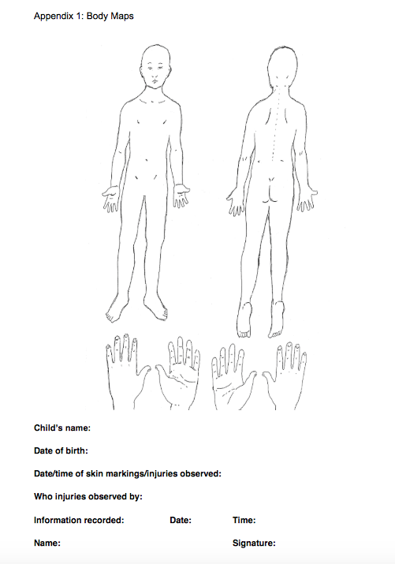

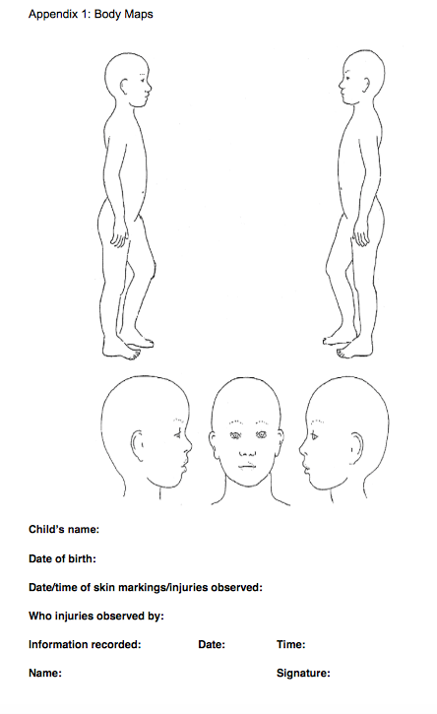

Appendix 2: Multi Agency Bruising Flowchart for Assessment of Bruising in a Child who is not Independently Mobile (Includes Disabled older children who are Not Independently Mobile)
